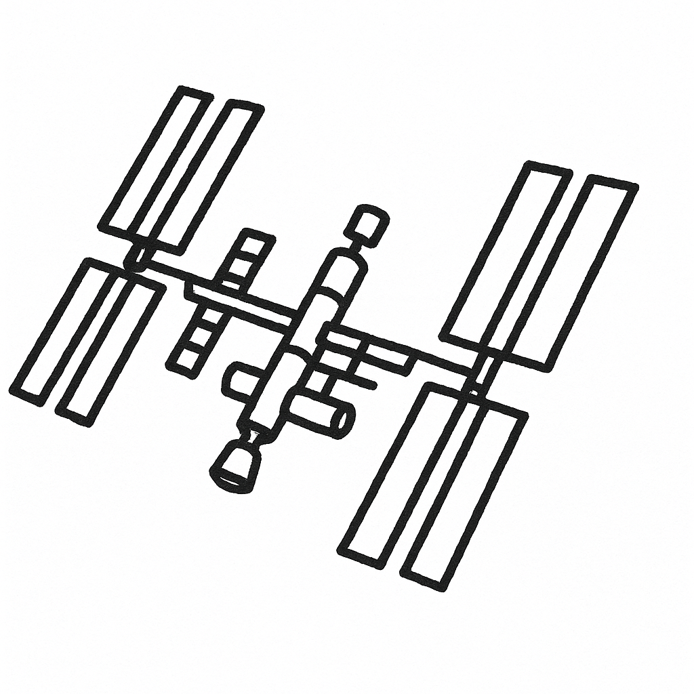
I was looking at the stars tonight and saw something that seemed to defy the laws of KNoWN PHYSiCs. Upon closer look, it was actually the International Space Station. We decided to create our own little satellite made out of Legos.

